**COAL Lab 1 Tasks**

**Task # 1:**

**Assembly Language Code:**

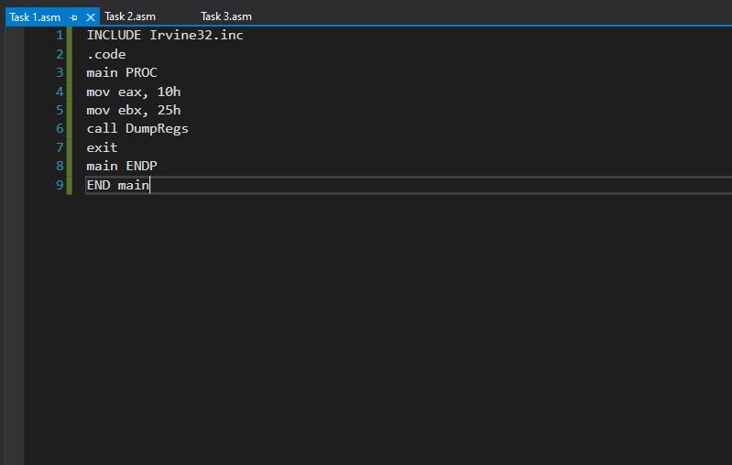

**Output:** 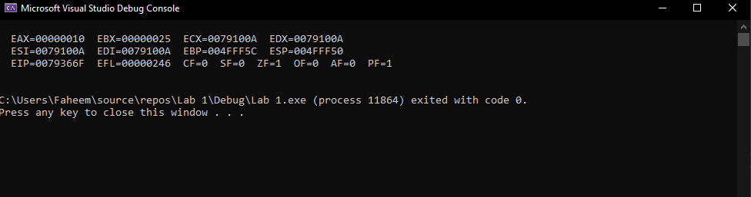

**Task # 2:**

**Assembly Language Code:**

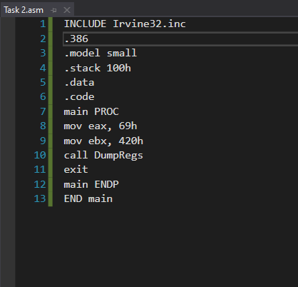

**Output:** 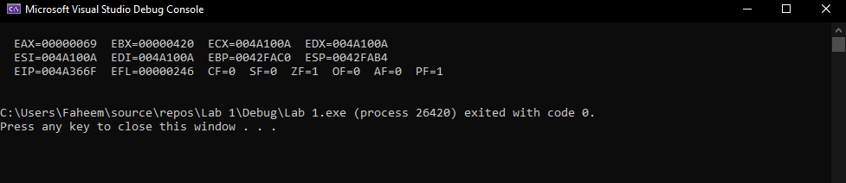

**Task # 3:**

**Assembly Language Code:**

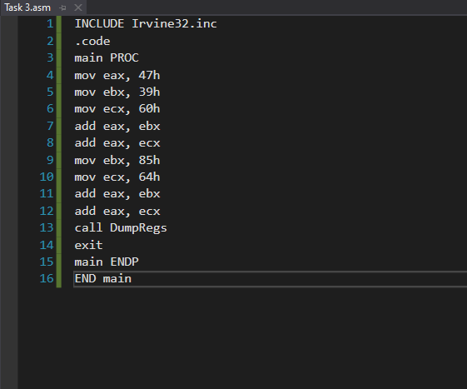

**Output:** 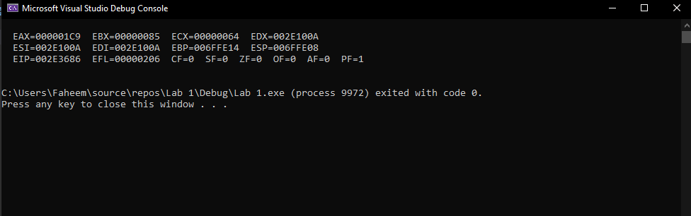

**Debugging Task:**

**Assembly Language Code:**



**Output: **

**Instruction # 1:**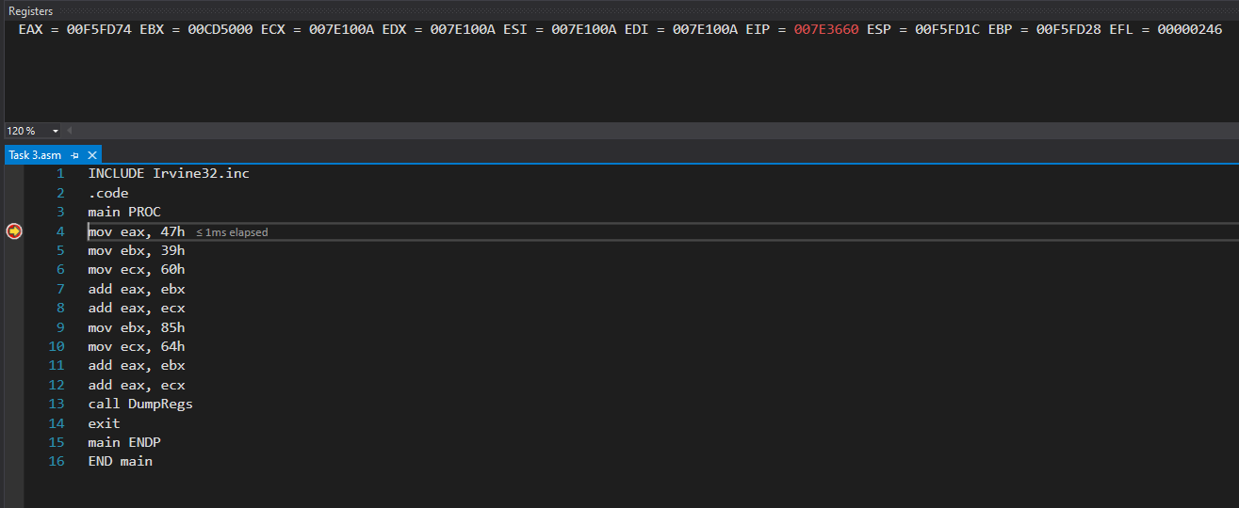

**Instruction # 2:** 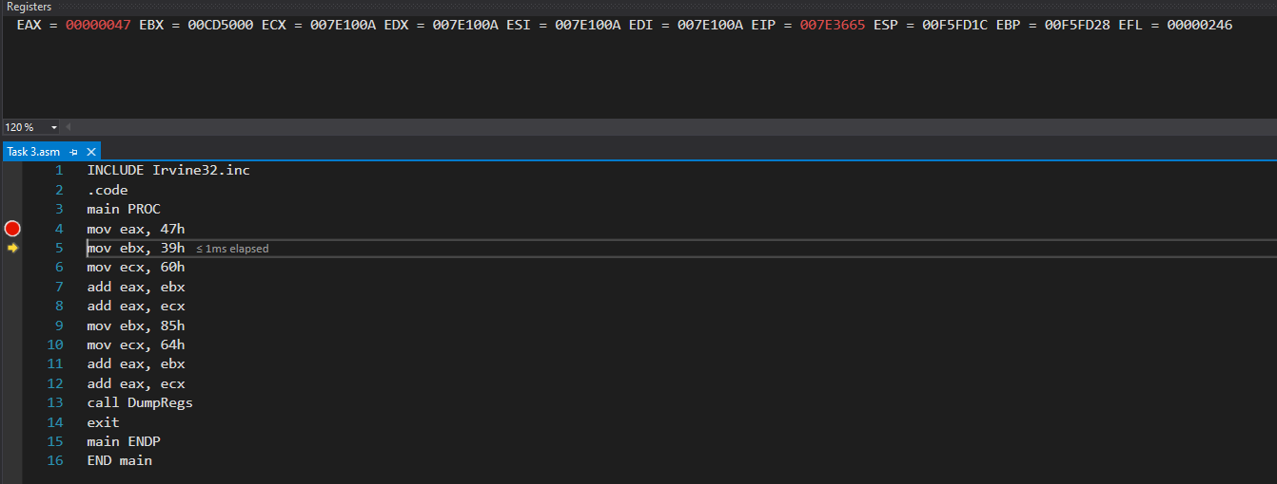

**Instruction # 3:** 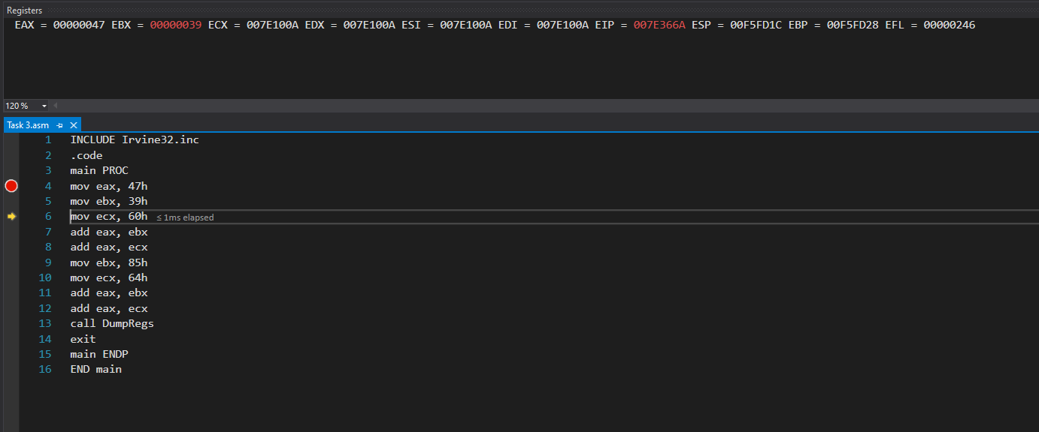

**Instruction # 4:** 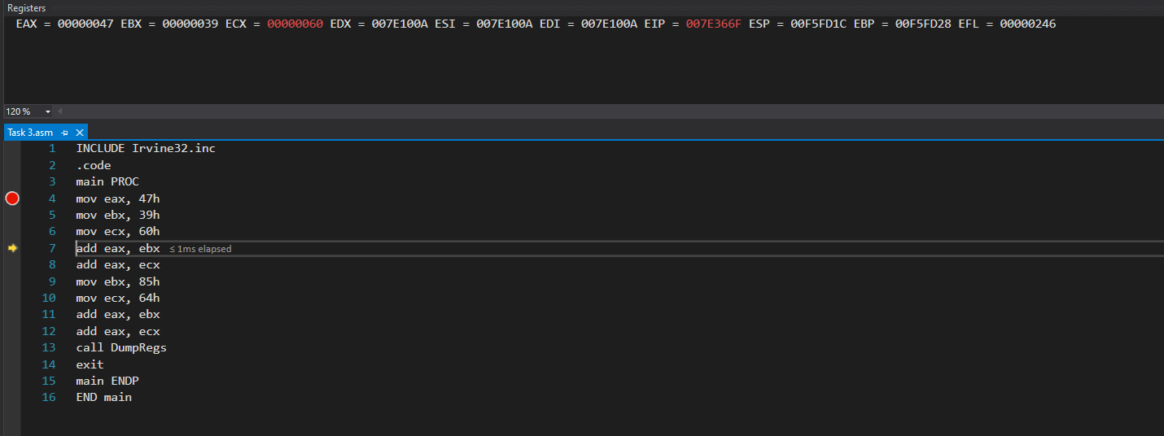

**Instruction # 5:** 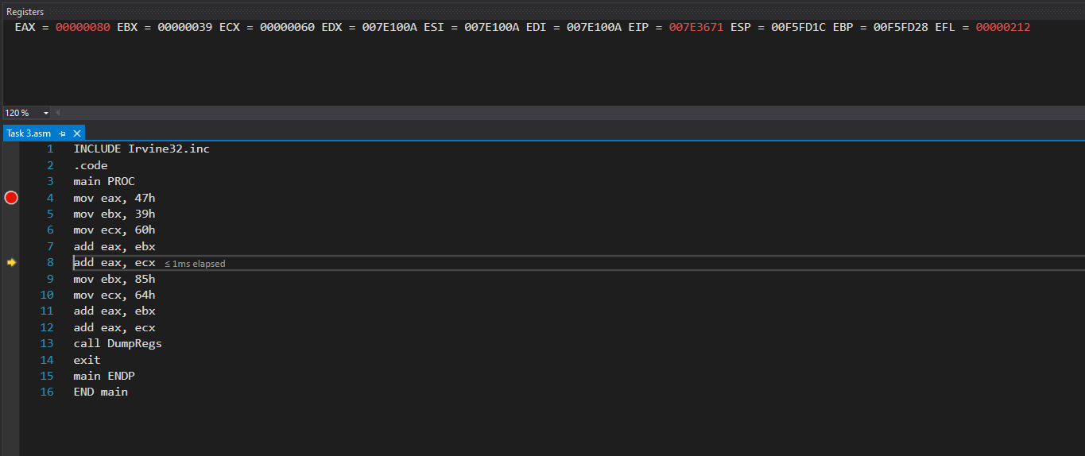

**Instruction # 6:** 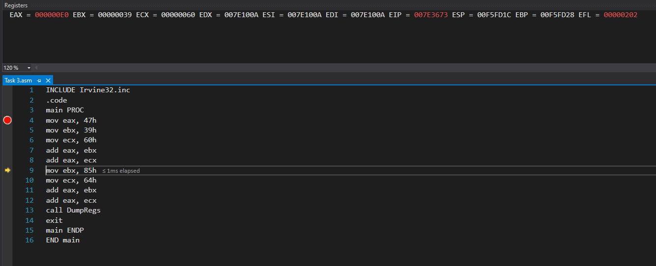

**Instruction # 7:** 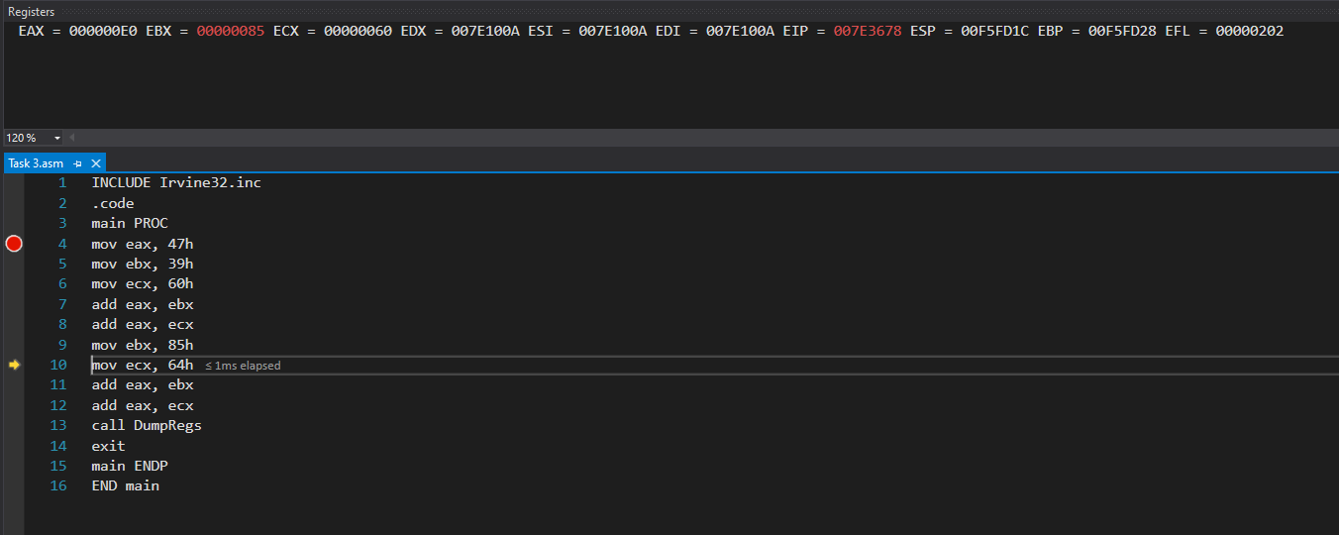

**Instruction # 8:** 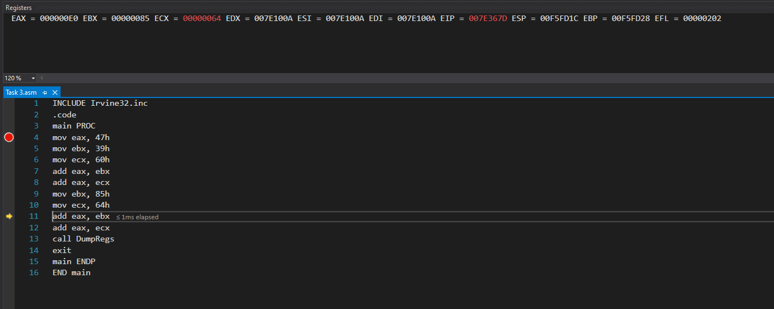

**Instruction # 9:** 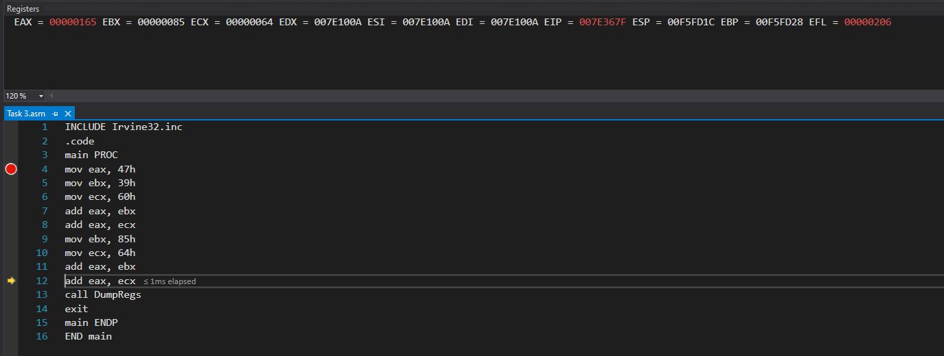

**Instruction # 10:**